|  |  |
| --- | --- |
| logo | Silver Route Horse Trail® |
| Equestrian Tourism: | 8 days - 7 nights - 5 days riding |

|  |
| --- |
| A horseback expedition that lets you enjoy stunning natural landscapes, going from semi-desert to oak forests and wetlands. From rugged mountains to valleys of cactus, ghost towns, Indian chapels and sites of great historical importance.  Get the chance to meet the unrecognized Mexico, while you will ride around colonial cities recognized as UNESCO World Heritage Site, magic towns, majestic shrines, traditional Mexican rural communities, always riding through the old Camino Real de Tierra Adentro, the "Silver Route",. It reborn with the arrival of the Spanish, who used this same path crossed by the Aztec messengers and nomadic tribes since ancient times.  You will live an unforgettable experience hearing the “earth sing” at every step of your horse.  You will ride in the same places where, hundreds of years ago, conquerors rode full of gold and silver, followed by the armies of independence in 1810 as well as the revolutionary, led by Pancho Villa in 1900.  This is undoubtedly the best offer to discover the hidden treasures of a 500 years history, through ancient trails, haciendas and colonial heritage sites recognized by UNESCO.  Guanajuato is considered as the geographic center of the country. Located in the heart of Mexico, it is also surrounded by some of the most representative Mexican sites, such as San Miguel de Allende, Atotonilco and Guanajuato, all declared by UNESCO as world heritage. |

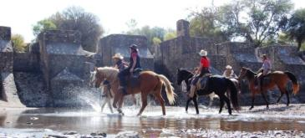

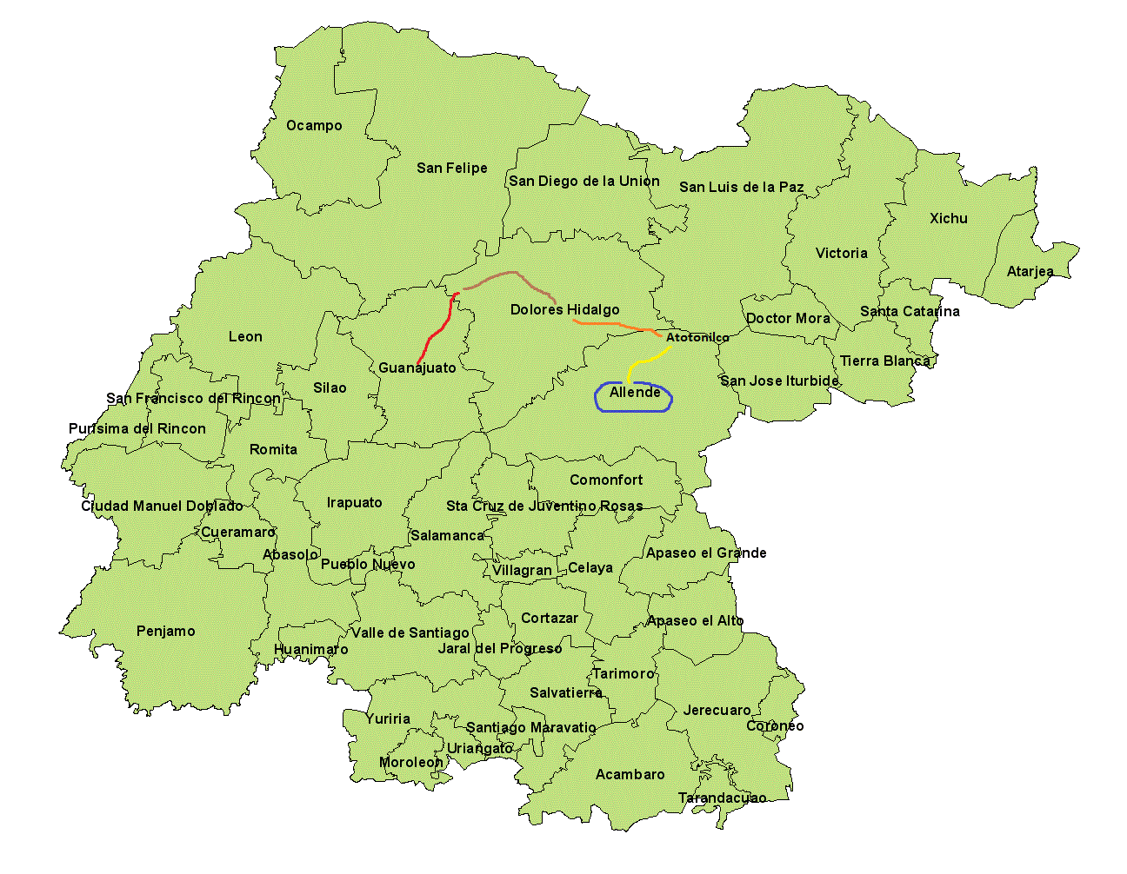

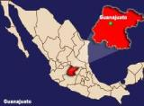

*Short description:*

* **Day 1 Guanajuato**. The most beautiful colonial city of Mexico, declared by UNESCO as WHS.
* **Day 2 Villa de Santa Rosa:** Nestled in the heart of the central highlands, surrounded by nature.
* **Day 3 Dolores Hidalgo:** Magic Town, and historic site where independence starts in 1810.
* **Day 4** **Atotonilco:** typical Mexican Villa, with a majestic eighteenth century sanctuary. Declared

a UNESCO World Heritage Site.

* **Day 5 San Miguel de Allende**. Founded in 1542 and now a cosmopolitan place,it has become an

attractive destination for tourists from all around the world. Declared by UNESCO.

* **Day 6**  **San Miguel de Allende.** During the morning, riding around the city, rest of the day free.
* **Day 7** Transfer back to **Guanajuato.** Rest of the day free.
* **Day 8** Private transfer to the airport or bus station. **\* End of program.**

|  |  |  |  |  |
| --- | --- | --- | --- | --- |
| Guanajuato | Silver Route ~ Horse Trail® | | | |
| Level required for riders: | Intermediary: A rider confident, and secure in all three paces | | | |
| Difficult terrain: | 65% easy- 30% intermediary – 5% difficult | | | |
| Physical effort required: | 85% easy 15 % Moderate | | | |
| Total duration: | 8 Days 7 Nights ( average accommodation ranking: 3.5 stars) | | | |
| Horsing : | 5 days (6 to 8 hours a day) | | | |
| Mounts type: | Charro & Western ( English) upon request | | | |
| Horses: | Quarter, appendix and Mexican Creole | | | |
| Pace: | Walk, trot and some gallops | | | |
| Equipment provided: | Saddle, Saddlebags, picnic mat, water bottle, bandana, Support vehicle for luggage. | | | |
| Limitations: | Weight | Max.110kilos | Age | 14 to 18: only with a letter signed by parents |
| Minimum of participants: | 4 Pax | | | |
| Maximum of participants: | 14 Pax | | | |

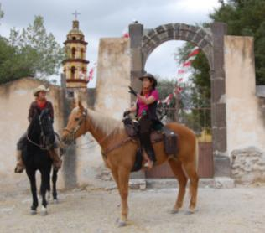

Ecoturismo y Aventuras de México DMC®

Q:\140066.esn\MEDIA\OFFICE14\Lines\BD21495_.gif

Álamo # 422 Col. Valle de León

León, Guanajuato. México c.p. 37140

Phone Numbers + 52 (477) 714 5757

Toll free méxico 01 800 ECO RUTA (326 78 82)

E-mail: [info@ecoturismoyaventuras.com.mx](mailto:info@ecoturismoyaventuras.com.mx)

**Skype: ecoturismoyaventuras**

**Facebook: ecoturismo.aventuras**